Hey Seth,

Looks to be working. Here are my notes based on my further testing:

- The first option should just say “Flush Channel”. Please remove the “- Flushed Channel”.

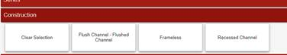
Done

- Channel Type is still showing up when we pick frameless. That needs to be resolved.
Done
- Please switch the order of Finish and Colour.
Done

- We need add a couple of more parent fields: “Horizontal Grain Direction” and “Legs”. Should I just do this or can you add the fields?
Horizontal Grain Direction should be a yes or no field

Legs should have the following options: if Series is SC Plus, then options are: Plastic 10cm or Plastic 15cm. Any other Series, the legs should be Steel 10cm or Steel 15cm
Please add this field on your end, after the setup on your end.
- In the main section, I would just like to show only the total price field. Can we remove the unit price and upcharge pct columns from the main screen and just show Total Price?
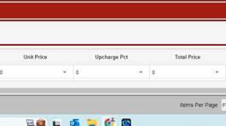
Done Made them LanOnly
- In the main section, can we move the “Description” field so it is right after the Item Field?
Done
- Also, in the item field, can we switch the values on the dropdown so that the code on the bottom is actually the code that is entered not the full code? So, in the example below, I only want the B100 to show in the Item field not the “B-100-72-60.5”. Is that possible? I will need to change the tab with all of the prices from the full code to the short code in order for the pricing to work as part of the lookup formula. Are these codes anywhere else in the SQL tables?
Done, but pricing formulas may have to be substantially changed now.
I have found a way to maintain the pricing formulas with only minor changes, by also creating a new property for the Full Config Code, to be used in the workbook as a lookup for the pricing variables. This can be made invisible, if the user doesn’t have to see it.
Done
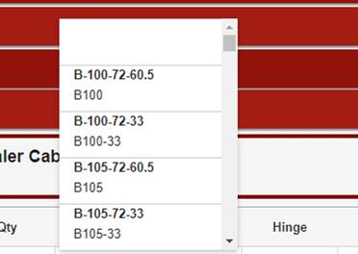

- There are codes that we are putting in where no values are showing in the W, H, D columns. B100 is an example of one. So that would need to get fixed.
Works randomly for all items, not consistent, need to be fixed.

- Lastly, I would need to what the plan is to make changes to the SQL tables when we add new doors, colours etc. Do you have a plan on how we update these items?

Otherwise, this looks amazing! I am excited to get to work on this. If you can make these changes as soon as possible, I can get to work.

Thanks
Anu

One more thing that I noticed…when selecting the species, “Engineered Veneer”, no colours are showing up.
Done

